SRN


School of Computer Science and Applications
II Semester MCA- IA1 Examination
July 2025
Course Code: M23DE0201 |  |  |  | Duration: 75 Mins
Course Title: Machine Learning |  |  |  | Max. Marks: 30
Q. No | Question | Marks | CO | PO | PSO | BL
Section A
Answer any two questions.
1 | - Define Machine Learning. Discuss the key applications of Machine learning. | 5 | 1 | 1 | 1,2 | L2
2 | - Explain over fitting and under fitting in model evaluation. | 5 | 1 | 2 | 2 | L2
3 | - Bring out the differences between classification and regression with examples. | 5 | 2 | 2 | 2 | L3
Section B
Answer all questions.
UNIT-I
4 | - a) What is the role of training data in model development? | 2 | 1 | 1 | 1 | L1
 | - b) What do you mean by Data preprocessing? Illustrate the various data preprocessing methods. | 8 | 1 | 1 | 1 | L2
OR
5 | - a) Compare traditional programming with machine learning approach. | 2 | 1 | 1 | 1 | L1
 | - b) Evaluation involves testing the Machine Learning model performance on unseen data. Explain any five evaluation metrics used in machine learning model. | 8 | 1 | 1 | 1,2 | L2
UNIT-II
6 | - What is the role of the kernel in SVM? | 2 | 2 | 2 | 1 | L1
 |  | 8 | 2 | 2 | 2 | L3
  b) Find the linear regression equation for the following set of data
  X | 0 | 1 | 2 | 3
  Y | 3 | 5 | 7 | 9
  Predict the value of Y when X = 5.
OR
7 | - Why KNN is called as a Lazy Learner? | 2 | 2 | 2 | 1 | L1
 | b) Given the following dataset, Find the probability of the students going to play cricket on the 15th day when weather condition are {Outlook=Sunny, Temperature=Cool, Humidity=High, Wind=Strong } using Naïve Baye’s Algithm.  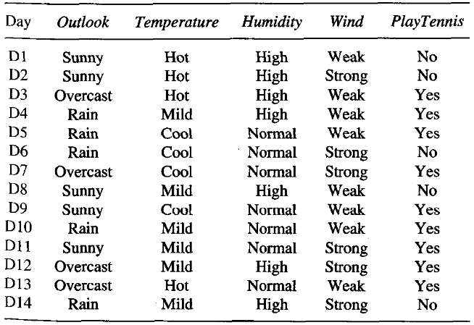 | 8 | 2 | 2 | 2 | L3

